Software Requirements Specification

Version 1.0

October 22, 2016

**Campus Tour Software**

Chitturi, Rakesh

Dande, Mallikharjuna Rao

Kotu, Chiranjeevi Sneha

Parimi, Teja

Prodduturi, Nayan Reddy

Solasa, Vamsi Krishna

Submitted in partial fulfillment

Of the requirements of

CSIS44-691 Graduate Directed Project 1

Table of Contents

Table of Contents i

List of Figures ii

1.0. Introduction 1

2.0. Overall Description 4

2.1 System Environment 4

2.2 Functional Requirements Specification 5

2.3 User Characteristics 15

2.4 Non-Functional Requirements 15

3.0. Requirements Specification 17

3.1 External Interface Requirements 17

3.2 Functional Requirements 17

3.3 Detailed Non-Functional Requirements 23

3.3.1 Security 25

Index 26

List of Figures

Figure 1 - System Environment 4

Figure 2 - Article Submission Process 6

Figure 3 - Editor Use Cases 8

Figure 4 - Logical Structure of the Article Manager Data 23

# 1.0. Introduction

## 1.1. Purpose

The purpose of this document is to present a detailed description of the Campus tour software. It will explain the purpose and features of the system, the interfaces of the system, what the system will do, the constraints under which it must operate and how the system will react to user input. This document is intended for both the stakeholders and the developers of the system and will be proposed to the client for approval.

## 1.2. Scope of Project

This will be a mobile application for students or users of Northwest Missouri state university (NWMSU). This application will be designed to maximize productivity by providing assistance to users to take a tour of the campus of NWMSU which would otherwise be a tedious task. By understanding the users need this application will be productive and useful to the users.

More specifically, the purpose of the application is to give a campus tour of Northwest Missouri State University. The audience will be the freshman students who joined the university and who want to get familiar with the infrastructure and the facilities provided at different locations in the university. This application is designed to allow the user to scan the QR Code of the building and get to know the details of the buildings in the campus and to keep a track of buildings visited with the help of a map using GPS. This software will facilitate communication between users GPS and campus buildings. The system also contains a relational database containing a list of Authors.

## 1.3. Glossary

|  |  |
| --- | --- |
| **Term** | **Definition** |
|  |  |
|  |  |
|  |  |
|  |  |
|  |  |
|  |  |
|  |  |
|  |  |
|  |  |
|  |  |
|  |  |
|  |  |
|  |  |

## 1.4. References

IEEE. *IEEE Std 830-1998 IEEE Recommended Practice for Software Requirements Specifications.* IEEE Computer Society, 1998.

## 1.5. Overview of Document

The next chapter, the Overall Description section, of this document gives an overview of the functionality of the product. It describes the informal requirements and is used to establish a context for the technical requirements specification in the next chapter.

The third chapter, Requirements Specification section, of this document is written primarily for the developers and describes in technical terms the details of the functionality of the product.

Both sections of the document describe the same software product in its entirety, but are intended for different audiences and thus use different language.

# 2.0. Overall Description

## 2.1 System Environment

Figure - System Environment

The purpose of the application is to give a campus tour of Northwest Missouri State University. The audience will be the freshman students who joined the university and who want to get familiar with the infrastructure and the facilities provided at different locations in the university.

## 2.2 Functional Requirements Specification

This section outlines the use cases for each of the active user separately.

### 2.2.1 Error Use Case

#### Use case: Error Flow of Campus Tour

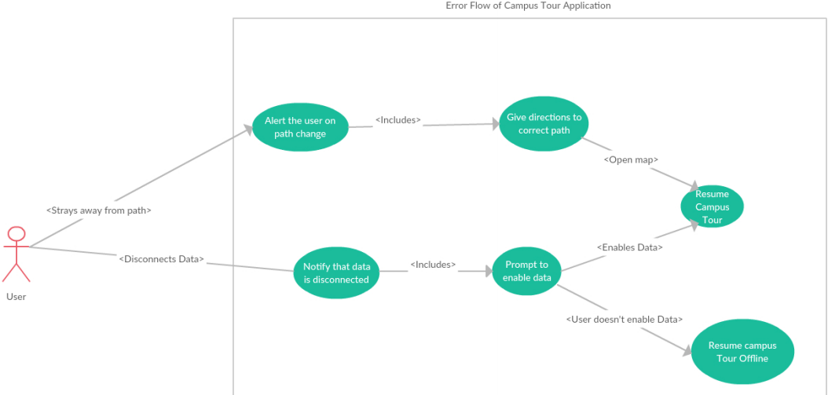

**Brief Description**

This use case describes about the error flow in the application. When the user disconnects from the network or goes away from the given direction.

**Initial Step-By-Step Description**

1. The user goes away from the path.
2. Alert the user about the path change.
3. After alerting the user the application gives the user the correct directions to the path.
4. When the user is in the correct direction as shown in the map the tour is resumed.
5. The second scenario is when the user disconnects from the network.
6. The application notifies the user when he is disconnected from the network asking him/her to connect to the network.
7. The application prompts the user to enable data.
8. After the user enables the data the application resumes with the campus tour.

### 2.2.2 QR Scan Use Case

#### 

#### Use case: QR Scan Functionality

**Diagram:**

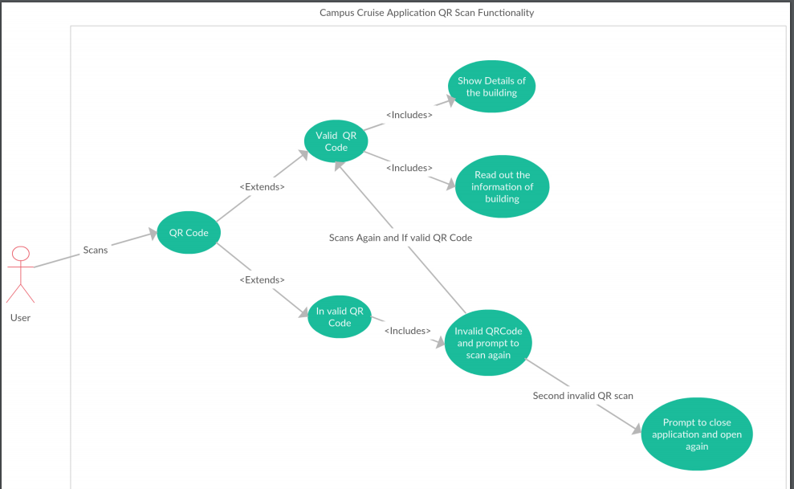

**Brief Description**

This use case describes about the QR Scan code. This gives a detailed description of how the user will scan the QR code and the functionality of this feature.

**Initial Step-By-Step Description**



### 2.2.3 Approaching Building Use Case

#### 

#### Use case: Approaching building Use case

**Diagram:**

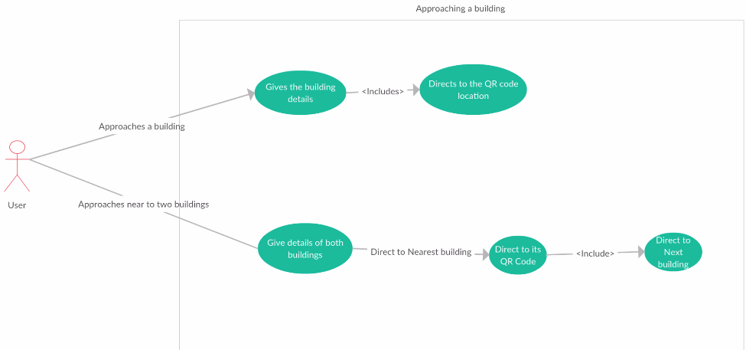

**Brief Description**

**Initial Step-By-Step Description**

## 2.3 User Characteristics

## 2.4 Non-Functional Requirements

* There should be uniformity in all the features of the application.

3.0. Requirements Specification

## 3.1 External Interface Requirements

The only link to an external system is the link to the Historical Society (HS) Database to verify the membership of a Reviewer. The Editor believes that a society member is much more likely to be an effective reviewer and has imposed a membership requirement for a Reviewer. The HS Database fields of interest to the Web Publishing Systems are member’s name, membership (ID) number, and email address (an optional field for the HS Database).

The *Assign Reviewer* use case sends the Reviewer ID to the HS Database and a Boolean is returned denoting membership status. The *Update Reviewer* use case requests a list of member names, membership numbers and (optional) email addresses when adding a new Reviewer. It returns a Boolean for membership status when updating a Reviewer.

## 3.2 Functional Requirements

* The Application should provide a Northwest Missouri State University (NWMSU) Campus tour
* The application should show the campus map of all the buildings and parking lots in and around the campus.
* The application should allow users to track their tour in the following stages,
* The application should be able to scan the QR Code placed outside the building to retrieve and record the information from it.
* The GPS in the system is linked with the QR Code and function accordingly.
* The application will be able to detect the active internet connection
* If the device is not connected to the internet application displays a message to the user asking him/her to connect to internet to proceed with the tour.
* If there is an active internet connection then the application proceeds with the tour.
* If GPS goes off in the middle of the tour then application displays a message asking the user to go to any nearest building in order to start the tour.
* If GPS is on and the user is not near to the campus map then the application displays a message to the user asking him/her to go the nearest building and starts the tour from that building.
* If the user is not in the range of the NWMSU campus then application tells user to go near the university in order to start the campus tour.
* QR Code placed outside the building, the GPS and in sync from the time the campus tour starts till the tour ends.

## 3.3 Detailed Non-Functional Requirements

### 3.3.1 Logical Structure of the Data

* There should be uniformity in all the features of the application.

### 3.3.2 Security

# Index

Abstract, 6, 17, 27

add, 9, 11, 19, 20, 21

Add, 8, 9, 19

Article, 1, 5, 6, 7, 8, 9, 10, 11, 12, 13, 14, 15, 16, 17, 18, 19, 20, 21, 22, 23, 24, 25, 26, 27, 28

Article Manager, 5, 8, 9, 10, 11, 12, 13, 14, 15, 16, 19, 20, 21, 22, 23, 24, 25, 28

Author, 1, 4, 5, 6, 7, 8, 9, 13, 14, 16, 17, 19, 20, 22, 23, 25, 26, 27

Category, 5, 14, 17, 18, 20, 21, 23, 26, 27

Database, 2, 9, 11, 14, 15, 16, 17, 18, 19, 20, 21, 22, 24, 25, 26, 27

Editor, 1, 4, 5, 6, 7, 8, 9, 10, 11, 12, 13, 14, 15, 16, 17, 19, 20, 21, 22, 23, 24, 25, 28

Field, 17, 19, 20

Form, 1, 6, 9, 10, 11, 12, 14, 19, 20, 21, 23, 24, 27

Grid, 9, 11, 12, 19, 20, 21

Historical Society, 1, 5, 9, 11, 16, 17, 19, 20, 26

Online Journal, 4, 5, 6, 7, 15, 16, 17, 18, 24, 27, 28

Reader, 4, 5, 6, 16, 17, 18

Review, 1, 7, 11, 12, 18, 21, 23, 26, 27

Reviewer, 1, 4, 5, 6, 7, 9, 11, 16, 17, 19, 20, 21, 22, 23, 26, 27

Security, 27, 28

Status, 11, 12, 13, 14, 17, 21, 22, 23, 27

update, 9, 11, 20, 21

Update, 8, 9, 10, 11, 12, 13, 14, 15, 17, 19, 20, 21, 22

User, 7, 16, 18

Web Publishing System, 1, 4, 5, 17